

# Project Proposal

# Course: Cse-311

# Faculty initial: ITN

# Section: 3

# Team: D

# Group Members:

# 🡺Ahmed Faizul Haque Dhrubo -2111026042

# 🡺Mohammad Akib-

# 2012574642

# 🡺Mohammad Tarem-

# 2021308642

# Library Management System

# Our final project will be a complete website where anyone can read books, add books by according their need anytime anywhere.

# At first there is a Super Admin which divided by 3 three which are Add Admin, Admin & Student/Teacher. In Super admin it can see students/teachers & admins and can also add new students & teachers. In admin part it can view books, add books, view students, issue books & approve request. In student/teacher it can view profiles, book request, view books, add fine.

# In front page there will be separate log in page one is Student Login & another one is Admin Login. There will be also a forgot password option so if anyone forgot their password so that they can again recover it.

# 

# Home:

# Sign up:

# 🡺Register as Student

# Students needs email and new password to register. 🡺Register as Teacher

# Teachers needs email and new password to register.

# Sign in:

# Whenever a student or teacher sign in with username and password they will be redirected to the corresponding account home page.

# Admin:

# 🡺Book Add

# Admin can add any kind of books which students want. 🡺Book view Admin can saw any books or if anyone need any books or not.

# 🡺Student view

# Students can read books without any hesitation.

# 🡺Issue book

# Students can borrow books so at first they need to issue books so that it can recorded which students borrow which books and when they return it.

# Students/Teachers:

# 🡺View profile

# Students and teachers can saw their profile that which day they read which books and how many books they read in one month. 🡺Book request

# If anyone need any book and if it is not available then they can request for that book so library management can buy that book and place it in library.

# 🡺Book view

# Anyone can search for any books and after reading they can leave a note for that book.

# 🡺Fine

# If anyone borrow any book and did not return it in due time then they will get fine for their mistake.

# Add Admin:

# 🡺View student/Teacher

# In this part they can monitor anyone that how many books they read or borrow last few days or anyone get any kind of fine. If anyone start violent then they can remove that person and take all kind of access from him/her.

# Languages:

# My SQL

# PHP

# Html

# CSS

Gantt-chart:  
https://prod.teamgantt.com/gantt/schedule/?ids=3147361#&ids=3147361&user=&custom=&company=&hide_completed=false&date_filter=&color_filter= 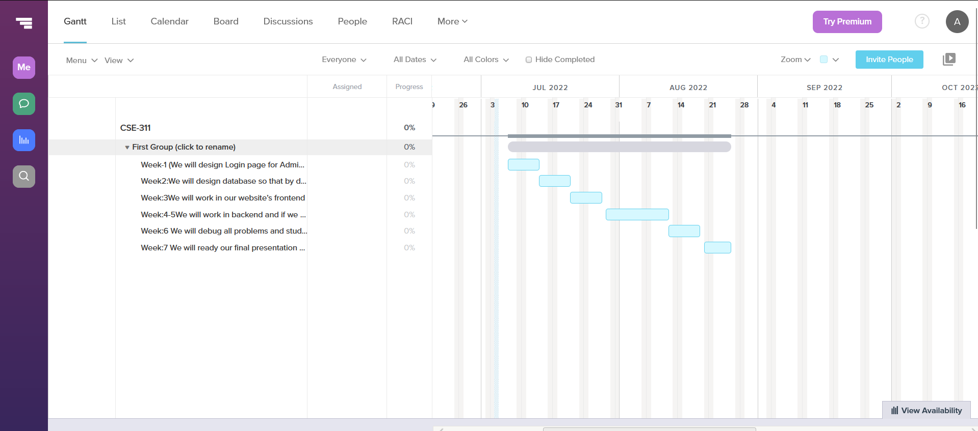

# Week:1

# We will design Login page for Admin & Students/Teachers

# Week2: We will design database so that by day by day we can easily implement those data.

# Week:3

# We will work in our website’s frontend part.

# Week:4-5

# We will work in backend and if we need any changes in our login page or frontend we will fixed it.

# Week:6

# We will debug all problems and study on that website how it works or didn’t it show any kind of problem or not.

# Week:7 We will ready our final presentation so that we can easily show it to everyone.

# Git-repository Link:

# https://github.com/Dhrubo3/Cse_311_project/commits?author=Dhrubo3&since=2022-06-30&until=2022-07-01